SIX MONTH INDUSTRIAL TRAINING
SYNOPSIS REPORT
ON
“ RESUME ANALZER AND SKILL MATCHER “

Submitted in partial fulfillment of the requirement for award of Degree of
MASTER OF COMPUTER APPLICATIONS


SESSION :- 2024 – 2026

SUBMITTED TO: SUBMITTED BY:
PROF . MANAV THAKUR SIMRAN
243830010109

MCA DEPARTMENT OF GOVT . COLLEGE UNA
HIMACHAL PRADESH TECHNICAL UNIVERSITY HAMIRPUR (HP)

Table of contents

S.NO. | TITLE | PAGE NO.
1 | Introduction to Project | 3-4
2 | Requirement Analysis and Literature Survey | 5-7
3 | Planning of the Project | 8-10
4 | Hardware and Software Requirements of the Project | 11-13
5 | Design of the Project | 14-17
6 | References | 18

CHAPTER – 1
INTRODUCTION TO PROJECT
  - Introduction to Project
The AI-Based Resume Analyzer and Skill Matcher is an intelligent recruitment assistance system designed to automate and enhance the hiring process using Artificial Intelligence. The project focuses on analyzing candidate resumes, extracting relevant information such as skills, qualifications, and experience, and matching them with job descriptions using Natural Language Processing (NLP) and Machine Learning (ML) techniques.
The scope of this project covers resume parsing, keyword extraction, skill identification, job-role matching, scoring mechanisms, and recommendation systems. It aims to reduce manual effort in recruitment, minimize human bias, and improve hiring accuracy by providing data-driven insights. The system can be used by HR professionals, recruitment agencies, and organizations to streamline the candidate shortlisting process efficiently.
  - Description of Project
The AI-Based Resume Analyzer and Skill Matcher is a web-based or software application that processes resumes in various formats (PDF, DOCX, TXT) and analyzes them using Artificial Intelligence techniques. The system extracts structured information such as personal details, educational qualifications, work experience, technical skills, certifications, and projects.
Using Natural Language Processing (NLP), the application identifies keywords and compares them with job descriptions stored in the database. A matching algorithm calculates a similarity score between the candidate’s profile and the job requirements. Based on this score, the system ranks candidates and provides suggestions regarding skill gaps and improvement areas.
Additionally, the project may include features such as resume scoring, job recommendation, skill gap analysis, and dashboard visualization for recruiters. The system enhances efficiency, ensures fair evaluation, and provides actionable insights for both recruiters and job seekers.
  - Objectives of Project

Specific Objectives
- To design and develop an AI-based system that automatically analyzes resumes.
- To implement NLP techniques for extracting and categorizing candidate skills.
- To create a skill-matching algorithm that compares resumes with job descriptions.
- To generate a resume score based on relevance and compatibility.

Measurable Objectives
- Achieve at least 80–90% accuracy in skill extraction and job-role matching.
- Reduce manual resume screening time by at least 50%.
- Provide ranking results with similarity score metrics for each candidate.

Achievable Objectives
- Utilize existing AI/ML libraries such as Python NLP libraries (e.g., spaCy, NLTK).
- Implement machine learning models for classification and similarity matching.
- Deploy the system as a web-based application using available frameworks.

Relevant Objectives
- To support modern recruitment systems with automation.
- To reduce human bias in hiring decisions.
- To help candidates understand missing skills required for specific roles.

CHAPTER – 2

REQUIREMENT ANALYSIS AND LITERATURE SURVEY

2.1 Existing Projects of Similar Characteristics
In the process of finalizing our project topic, we reviewed several existing systems that perform resume parsing and job matching in limited capacities. Many online job portals like Linkedin, Indeed, and Naukri offer basic keyword-based search to filter candidates, but these largely depend on simple string matching rather than intelligent semantic analysis.
Research projects and tools such as Resume Parser APIs, CV analyzers, and basic applicant tracking systems (ATS) extract candidate data using template-based or heuristic methods which often fail to accurately interpret varied resume formats and rich context. Some academic tools use rule-based NLP, but they lack advanced skill matching and recommendation capabilities.
Key observations from existing systems:
- Resume parsing often fails with non-standard formats.
- Most systems use simple keyword matching without semantic understanding.
- Limited ability to recommend skill improvements or match candidates intelligently.
This highlighted the need for a more advanced AI-driven system capable of deep semantic understanding and smart skill matching.

2.2 Need to develop this Project
Although recruitment tools exist, they do not effectively solve real world hiring challenges due to limited intelligence and automation. The main reasons for developing this project are:
- Automation of Manual Screening: Recruiters spend significant time reviewing resumes manually. Our system reduces this burden by intelligently analyzing resumes.
- Improved Accuracy: Traditional keyword matching overlooks context, leading to inaccurate shortlisting.
- Semantic Skill Matching: Leveraging Natural Language Processing helps uncover equivalent skills even when worded differently.
- Fair Hiring: Reduces human bias by focusing on skills and qualifications objectively.
- Candidate Insight: Helps job seekers identify skill gaps and areas for improvement to match desired roles.
2.3 Course of Action
To develop this AI-based system, the following planned steps will be executed:
- Requirement Study and Planning
  - Identify user requirements (HR and Job seekers)
  - Determine system features and functionalities
- Data Collection and Preprocessing
  - Gather sample resumes and job descriptions
  - Convert varied formats (PDF, DOCX) into structured text
- Resume Parsing Module Development
  - Extract meaningful fields (name, skills, experience, etc.)
  - Use NLP to tokenize and interpret content
- Skill Extraction and Normalization
  - Implement techniques to identify skills and map related terms
  - Use predefined skill ontology or dictionary
- Job Description Matching Logic
  - Develop algorithm to compare candidate profile with job requirements
  - Calculate similarity and relevance scores
- Recommendation and Reporting
  - Provide ranked list of candidates
  - Suggest skills for improvement
- Testing and Validation
  - Test system with varied resume sets
  - Improve accuracy through iterative refinement
- Deployment and UI Development
  - Build user interface for recruiters and applicants
  - Deploy as web or desktop application
2.4 Literature Survey
During the literature survey for project conceptualization, we reviewed several research papers, articles, and open-source tools related to resume analysis and job matching. The main themes found in literature include:
- Natural Language Processing Applications in Recruitment: Many studies focus on resume parsing using NLP techniques such as Named Entity Recognition (NER), tokenization, and part-of-speech tagging. These help extract key elements like experience, skills, education, etc.
- Machine Learning-Based Matching: Research emphasizes the use of semantic similarity measures like cosine similarity, word embeddings (e.g., Word2Vec), and TF-IDF vectorization to compare candidate profiles with job descriptions.
- Deep Learning Enhancements: Some papers proposed using advanced models such as BERT and Transformer-based architectures for contextual understanding of text, improving matching precision far beyond rule-based systems.
- Skill Ontologies and Knowledge Graphs: Literature also explains constructing structured skill databases or ontologies to normalize synonymous skills (e.g., “ML” and “Machine Learning”).

CHAPTER – 3

PLANNING OF THE PROJECT

3.1 Objectives of Project
The main objective of the AI-Based Resume Analyzer and Skill Matcher project is to design and develop an intelligent system that automates resume screening and accurately matches candidate profiles with job descriptions using Artificial Intelligence techniques. The system aims to reduce manual workload, improve hiring efficiency, and provide data-driven insights for both recruiters and job seekers.
By the final submission of the project, we plan to achieve a fully functional prototype capable of extracting resume data, identifying technical and soft skills, calculating similarity scores, ranking candidates, and generating skill-gap recommendations. The project will integrate Natural Language Processing (NLP) and Machine Learning (ML) algorithms to ensure accurate and efficient resume analysis.

Main Objectives Planned:
- To design a system architecture for AI-based resume analysis.
- To develop a resume parsing module that extracts structured information from resumes.
- To implement skill extraction using NLP techniques.
- To design and implement a job-role matching algorithm.
- To generate similarity scores and candidate rankings.
- To provide skill-gap analysis and improvement suggestions.
- To develop a user-friendly interface for recruiters and candidates.
- To test and validate system accuracy and performance.
- To deploy the system as a functional application before final submission..
Bottom of Form

3.2 Planned Steps to Achieve above Objectives
To successfully complete the project, the following step-by-step course of action has been planned:

Step 1: Requirement Analysis and Planning
- Identify system users (Recruiters and Job Seekers).
- Define functional and non-functional requirements.
- Prepare project timeline and milestone plan.
- Finalize technology stack (e.g., Python, NLP libraries, database, web framework).

Step 2: System Design
- Design system architecture (Frontend, Backend, Database).
- Create data flow diagrams and module diagrams.
- Plan database schema for storing resumes, job descriptions, and scores.
- Define workflow for resume upload and matching process.

Step 3: Data Collection and Preparation
- Collect sample resumes in different formats (PDF, DOCX).
- Collect various job descriptions for testing.
- Convert resumes into machine-readable text.
- Clean and preprocess textual data (remove stopwords, normalize text).

Step 4: Resume Parsing Module Development
- Implement text extraction from documents.
- Apply NLP techniques for:
  - Tokenization
  - Named Entity Recognition (NER)
  - Skill extraction
- Extract key fields such as:
  - Name
  - Education
  - Experience
  - Skills
  - Certifications

Step 5: Skill Matching and Scoring Algorithm
- Develop a skill database or skill dictionary.
- Use techniques such as TF-IDF or cosine similarity to compare resumes with job descriptions.
- Calculate a matching percentage score.
- Rank candidates based on similarity score.

Step 6: Skill Gap Analysis and Recommendation System
- Identify missing skills required for specific job roles.
- Provide suggestions to candidates for improvement.
- Generate resume evaluation reports.

Step 7: User Interface Development
- Develop frontend interface for:
  - Resume upload
  - Job description input
  - Viewing results
- Create dashboard for recruiters to view ranked candidates.

Step 8: Testing and Validation
- Perform functional testing for each module.
- Validate accuracy of skill extraction and matching.
- Optimize performance and improve algorithm efficiency.
- Conduct user testing and gather feedback.

Step 9: Deployment and Documentation
- Deploy the system on local server or cloud platform.
- Prepare final project documentation.
- Create presentation slides and demonstration materials.
- Submit final working prototype.

CHAPTER – 4

HARDWARE AND SOFTWARE REQUIREMENTS FOR THE PROJECT

4.1 Hardware Requirements
The project does not require highly specialized hardware; however, sufficient computational capability is necessary to handle text processing, model training, and similarity calculations.

Minimum Hardware Requirements:
- Processor: Intel i5 / AMD Ryzen 5 or higher
- RAM: Minimum 8 GB (16 GB recommended for ML model training)
- Storage: 256 GB SSD or higher
- System Type: 64-bit Operating System
- Internet Connection: Required for downloading libraries, APIs, and deployment

Optional (For Advanced Implementation):
- GPU support (NVIDIA GPU) for faster deep learning model training
- Cloud server (AWS, Azure, or Google Cloud) for deployment
4.2 Software Requirements
The software environment includes programming languages, libraries, frameworks, and operating systems necessary for development and deployment.

Operating System:
- Windows 10/11
- Linux (Ubuntu preferred)
- macOS

Programming Language:
- Python (Primary language for AI/ML implementation)

Libraries and Frameworks:
- LangChain
- PyPDFLoader / PDFPlumber Loader
- RecursiveCharacter TextSplitter
- OpenAI Embeddings/HuggingFace Sentence Transformers
- Streamlit
- NLP Libraries: NLTK, spaCy
- Machine Learning Libraries: Scikit-learn
- Data Processing: Pandas, NumPy
Models
- OpenAI GPT-4 / GPT- 3.5 OR HuggingFace LLM(Mistral / LLaMA)

Database
- ChromaDB/FAISS
- MySQL / PostgreSQL (Relational database)
or
- MongoDB (NoSQL database)
4.3 Tools used for development of project
Various development tools are used to design, implement, test, and deploy the system effectively.

Development Tools:
- Visual Studio Code / PyCharm – Code Editor
- Jupyter Notebook – Model testing and experimentation
- Git & GitHub – Version control
- Postman – API testing
- XAMPP / Localhost Server – Backend testing
- Draw.io / Lucidchart – System architecture design

Deployment Tools (Optional):
- Heroku / AWS / Google Cloud – Hosting
- Docker – Containerization
These tools help in structured development, debugging, collaboration, and deployment of the system.
4.4 Techniques used for development of project
The AI-Based Resume Analyzer and Skill Matcher uses several machine learning and natural language processing techniques to extract and match candidate skills effectively.

1. Natural Language Processing (NLP) Techniques
- Tokenization: Breaking text into words and sentences.
- Stop-word Removal: Eliminating irrelevant words.
- Lemmatization/Stemming: Converting words to root form.
- Named Entity Recognition (NER): Identifying names, organizations, skills, etc.

2. Text Vectorization Techniques
- TF-IDF (Term Frequency – Inverse Document Frequency): Converts textual data into numerical vectors for similarity comparison.
- Bag of Words (BoW): Represents text as word frequency vectors.

3. Machine Learning Algorithms
Depending on implementation complexity, the following algorithms may be used:
- Cosine Similarity: Measures similarity between resume and job description vectors.
- K-Nearest Neighbors (KNN): Used for classification or recommendation based on similarity.
- Linear Regression: Can be used for predicting resume scores.
- Naïve Bayes Classifier: For text classification tasks.
- Support Vector Machine (SVM): For resume-job category classification.

4. Advanced Techniques (Optional Enhancement)
- Word Embeddings (Word2Vec, GloVe): For semantic similarity.
- BERT (Transformer-based model): For deep contextual text understanding.
- Clustering Algorithms (K-Means): To group similar resumes.

CHAPTER – 5

DESIGN OF THE PROJECT

5.1 ER/DFD/Flow Chart Diagrams
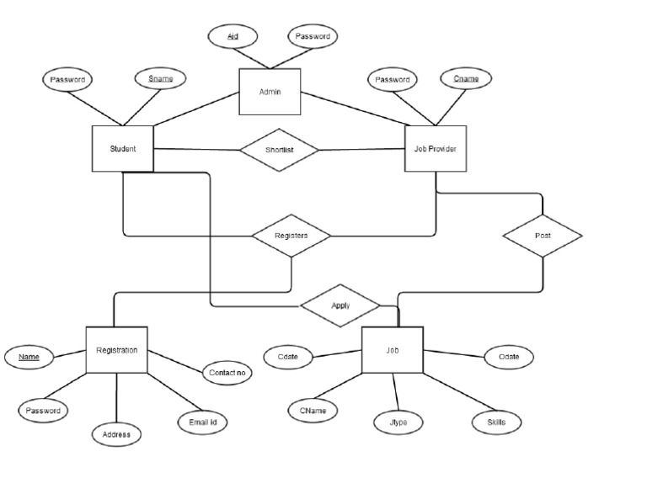
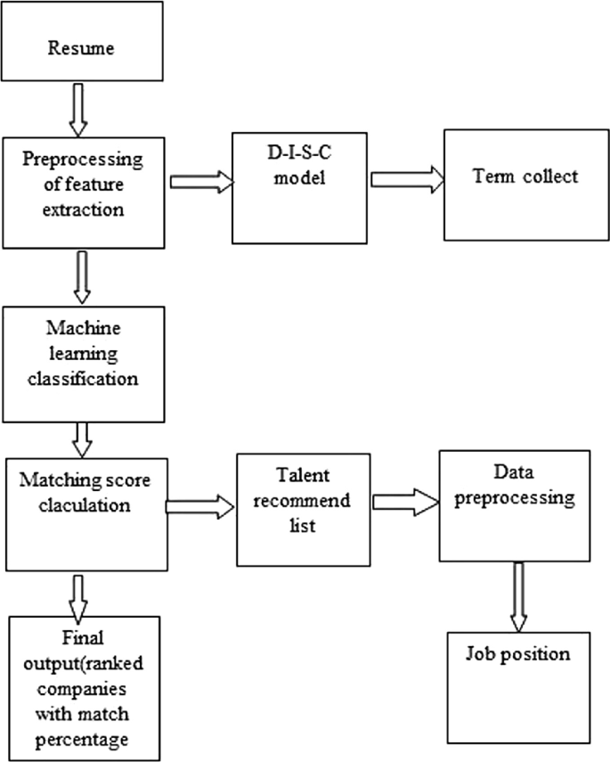

5.2 Class Diagram to show relationship amongst database tables
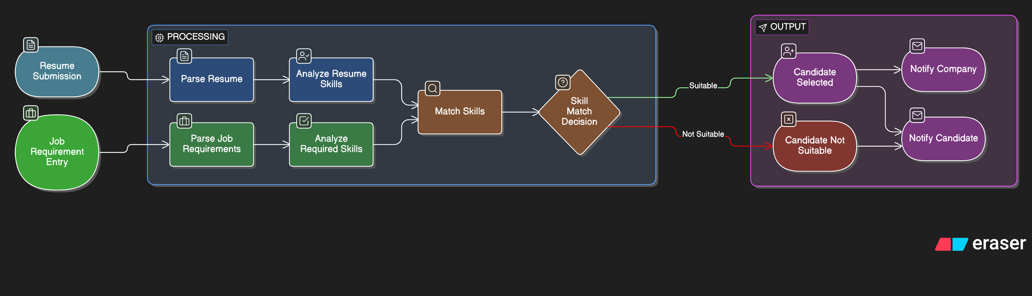
5.3 Database Tables
Below are the table structures used in the project:

1. Users Table
- user_id (INT, Primary Key, Auto Increment)
- name (VARCHAR 100)
- email (VARCHAR 100, Unique)
- password (VARCHAR 255)
- role (ENUM: Candidate, Recruiter)
- created_at (TIMESTAMP)

2. Resumes Table
- resume_id (INT, Primary Key)
- user_id (INT, Foreign Key)
- file_path (VARCHAR 255)
- extracted_text (TEXT)
- upload_date (DATE)

3. Skills Table
- skill_id (INT, Primary Key)
- skill_name (VARCHAR 100)
- category (VARCHAR 100)

4. Jobs Table
- job_id (INT, Primary Key)
- recruiter_id (INT, Foreign Key)
- job_title (VARCHAR 150)
- job_description (TEXT)
- experience_required (INT)
- posted_date (DATE)

5. Resume_Skills Table (Junction Table)
- id (INT, Primary Key)
- resume_id (INT, Foreign Key)
- skill_id (INT, Foreign Key)

6. Job_Skills Table (Junction Table)
- id (INT, Primary Key)
- job_id (INT, Foreign Key)
- skill_id (INT, Foreign Key)

7. Match_Results Table
- match_id (INT, Primary Key)
- resume_id (INT, Foreign Key)
- job_id (INT, Foreign Key)
- match_score (FLOAT)
- missing_skills (TEXT)
- matched_date (DATE)

CHAPTER – 6

REFERENCES

The development of the AI-based Resume Analyzer and Skill Matcher project is grounded in extensive research across Natural Language Processing (NLP), Machine Learning (ML), Information Retrieval, and Human Resource Analytics. Foundational concepts were referred from the book Speech and Language Processing by Jurafsky and Martin, which provided insights into text preprocessing, tokenization, named entity recognition, and semantic analysis techniques essential for resume parsing. Research papers such as “Resume Information Extraction using Named Entity Recognition” published in IEEE conferences offered guidance on extracting structured data from unstructured resumes using NLP models. Studies from journals like the International Journal of Computer Applications (IJCA) and IEEE Xplore were consulted to understand machine learning approaches for job-resume matching and classification algorithms including Support Vector Machines, Naïve Bayes, and Random Forest.
Additionally, online resources and documentation played a key role in system implementation. The official documentation of libraries such as TensorFlow, Scikit-learn, and SpaCy were referred to for implementing machine learning models and NLP pipelines. Articles from platforms like Kaggle provided datasets and practical insights into resume classification problems, while research blogs and technical tutorials from Medium and Towards Data Science helped in understanding real-world AI recruitment systems. Websites such as GeeksforGeeks and Stack Overflow were used for resolving coding challenges and improving algorithm efficiency. Furthermore, research on AI-based recruitment systems and Applicant Tracking Systems (ATS) from reputed HR technology platforms contributed to understanding industry standards and evaluation metrics. These combined academic, technical, and practical resources formed the theoretical and implementation foundation of the Resume Analyzer and Skill Matcher project.

